Operating System for Interview

Why OS ?

* To run any App, we need Computer and as we know computer consist of CPU, GPU, Disk and Ram. So if there is No OS then whole app will hijack the Computer and use whole Memory, CPU, GPU and it will not allow to run any other App.
* So OS Layer Above computer will help to provide resource Management i.e to give some % of Computer for particular App.
* If Not OS, then to run any App, we will require to write memory Management Code also, so App Size will also Increase.
* If there is No OS, Isolation and Security will be affected, i.e Every App Running will have to Allocate some memory and every app allocated memory will have to be Isolated from each other so 1 App cant write on Other App memory.

Function of OS

* OS will provide all functionalities mentioned above. And Act as an Interface between App and Computer.
* OS Will Not Allowed App to access Hardware directly.

What is OS

* An operating system is a piece of software that manages all the resources of a computer

system, both hardware and software, and provides an environment in which the user can

execute his/her programs in a convenient and efficient manner by hiding underlying

complexity of the hardware and acting as a resource manager.

Goals of OS

* Maximum CPU Utilization
* Minimize Process Starvation
* High priority execution

Types of OS

* Single process OS e.g MS DOS
* Batch processing OS it sort the jobs in batches .here operator is OS. e.g ATLAS

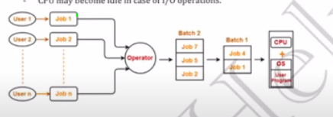

* Multiprogramming OS use single CPU only,but this use **context switching and process control board [PCB]** concept, where every job of cpu will be in queue and if some job will go in waiting period then cpu will switch to other Job, all job list present in process Control board data Structure. E.g THE
* MultiTasking OS -> this is same as Multiprogramming OS but also support Time Sharing, i.e every process will be shared to cpu for specific amount of time. This support all type of OS Goals.

E.g CTSS

* MultiProcessing-> this have Multiple CPU, this will help when any CPU gets stop because of some reason like hardware problem. E.g windows
* Distributed OS -> this is loosely coupled OS where OS is connected to Different CPU in same Network, like CPU connected with LAN. E.g AIX OS
* Real Time OS-> to get highest performance and accuracy. E.g Air Traffic Controller (ATC), ROBOTS

//Red are Important//

MultiThreading Concept:

When certain program runs it comes in Memory(RAM) is called Process.

Thread are light weight Process.

i.e let process is divided into two independent Task1(T1->thread1) and Task2(T2->thread2)

Multithreading may have single or or Multiple Processor.

To handle Multiple process simultaneously handle we must have multiple processor, however Multithreading is subtasks in single process.

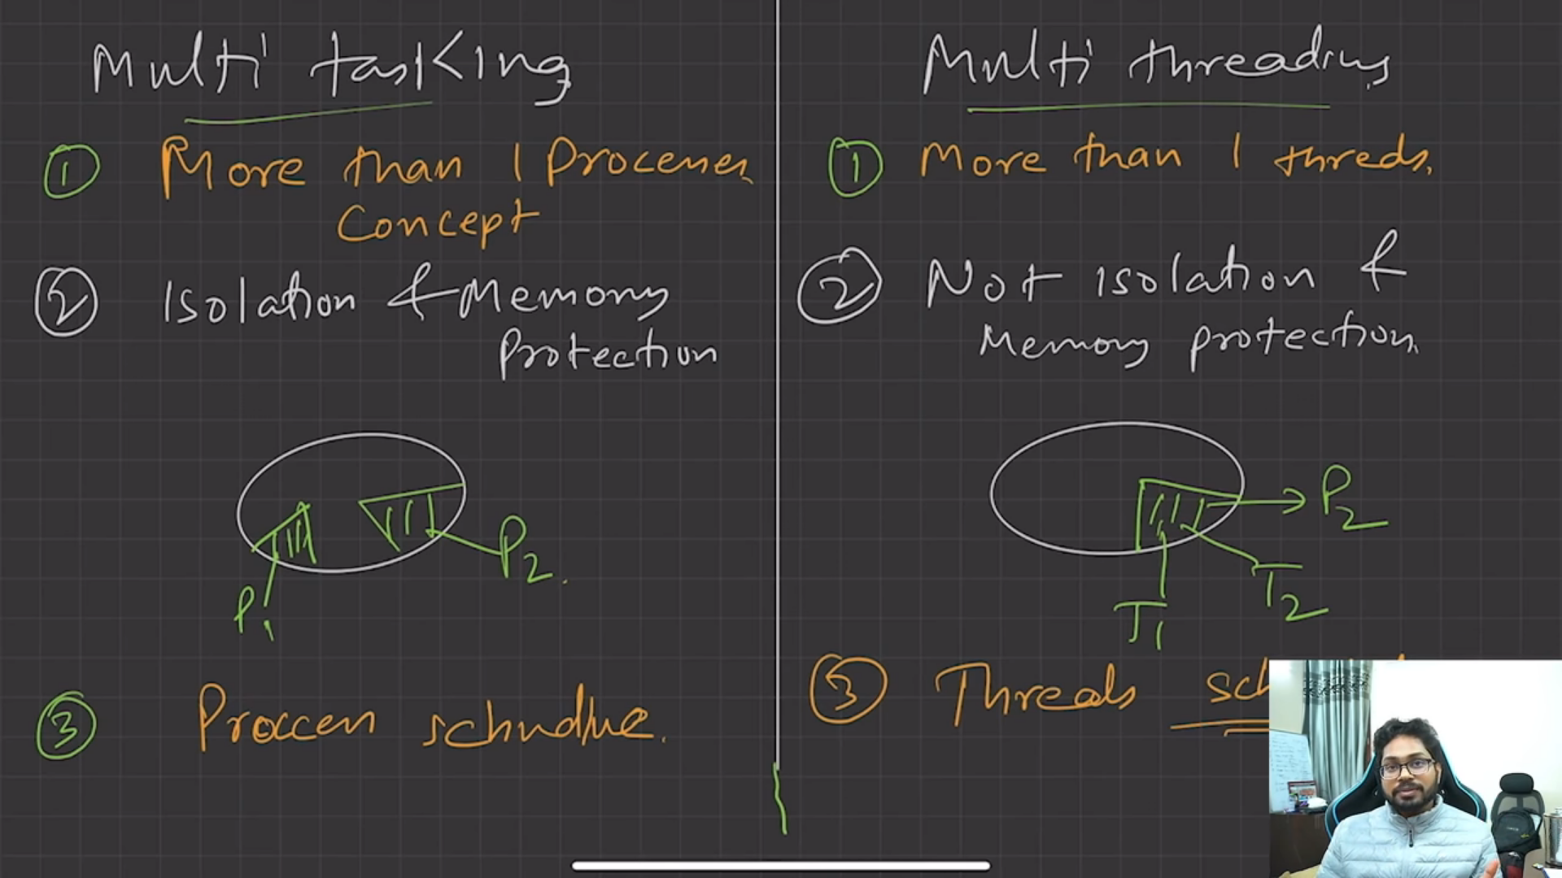

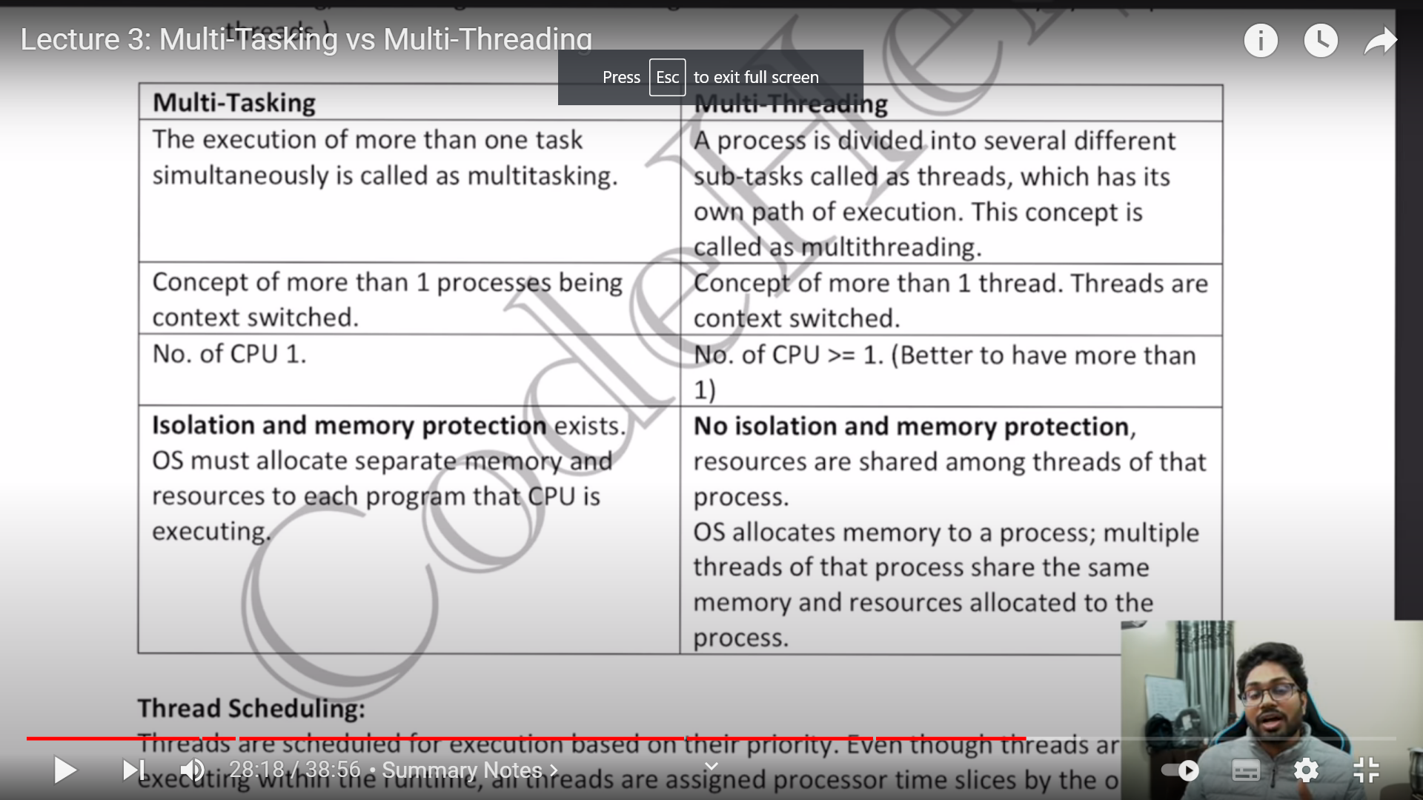

Components of OS:

1. UserSpace : the space for running the Apps
2. Kernel : kernel has access to underlying hardware

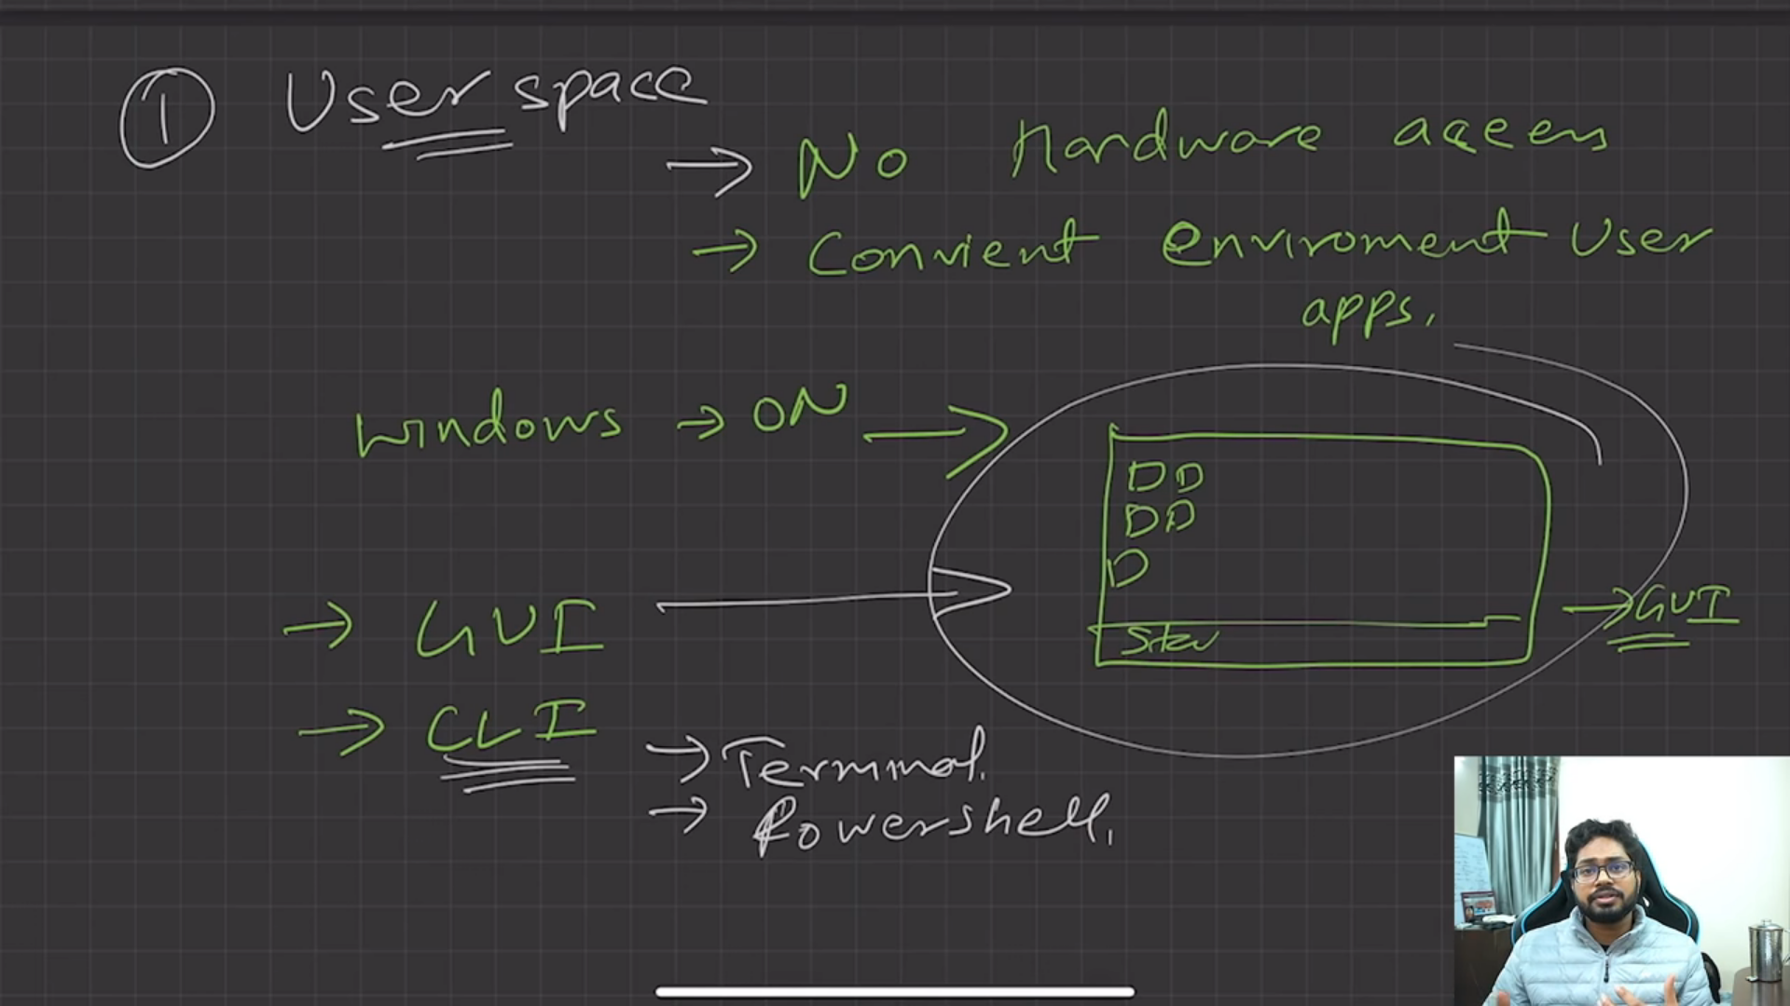

Gui -> graphical user Interface, gui behind the scene runs use CLI only.

CLI -> Command line interface

UserSpace Interacts with kernel.

What is kernel?

Kernel is heart of OS, and Interacts with hardware.

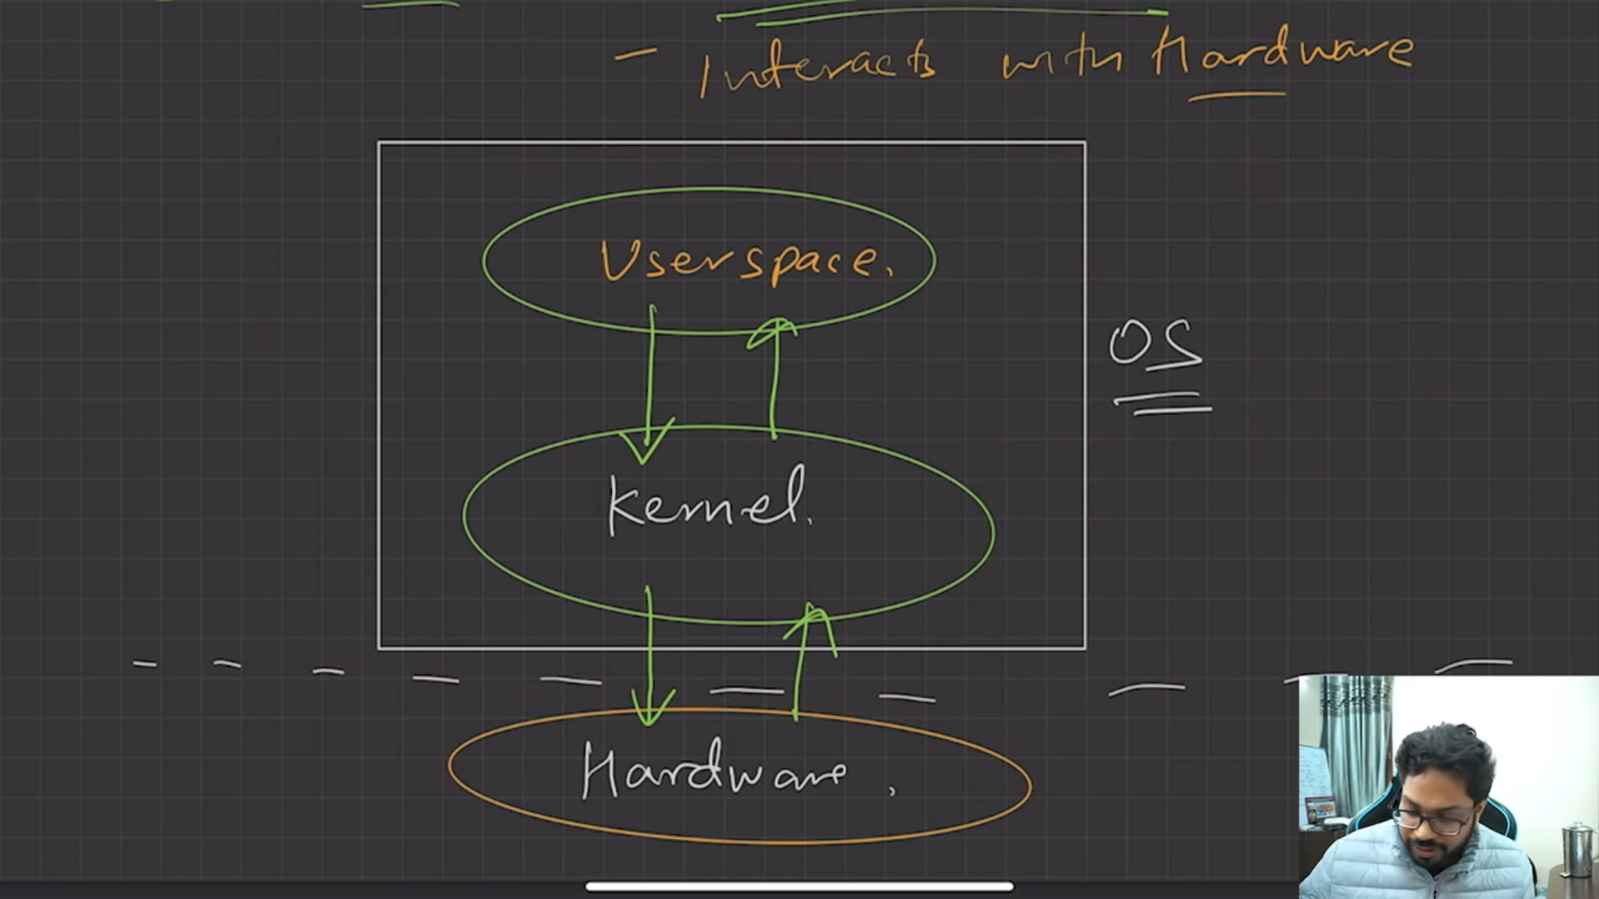

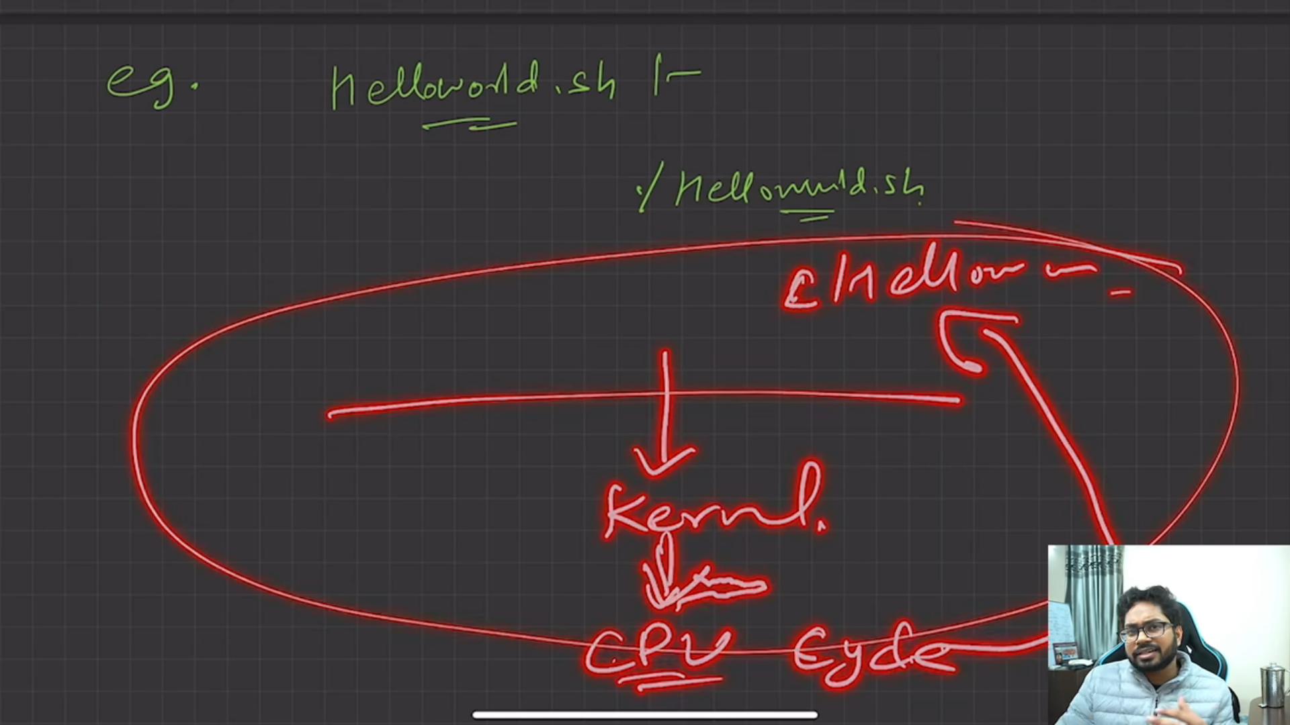

When need to do some execution kernel contact cpu and return output to kernel

Functions of Kernel:

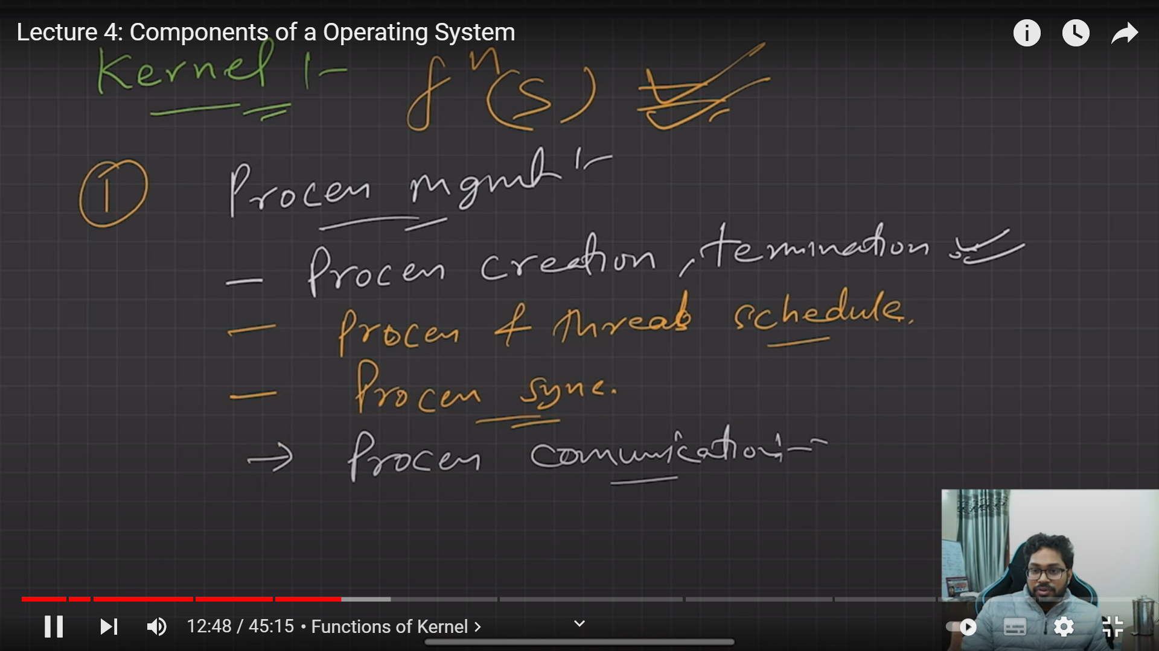

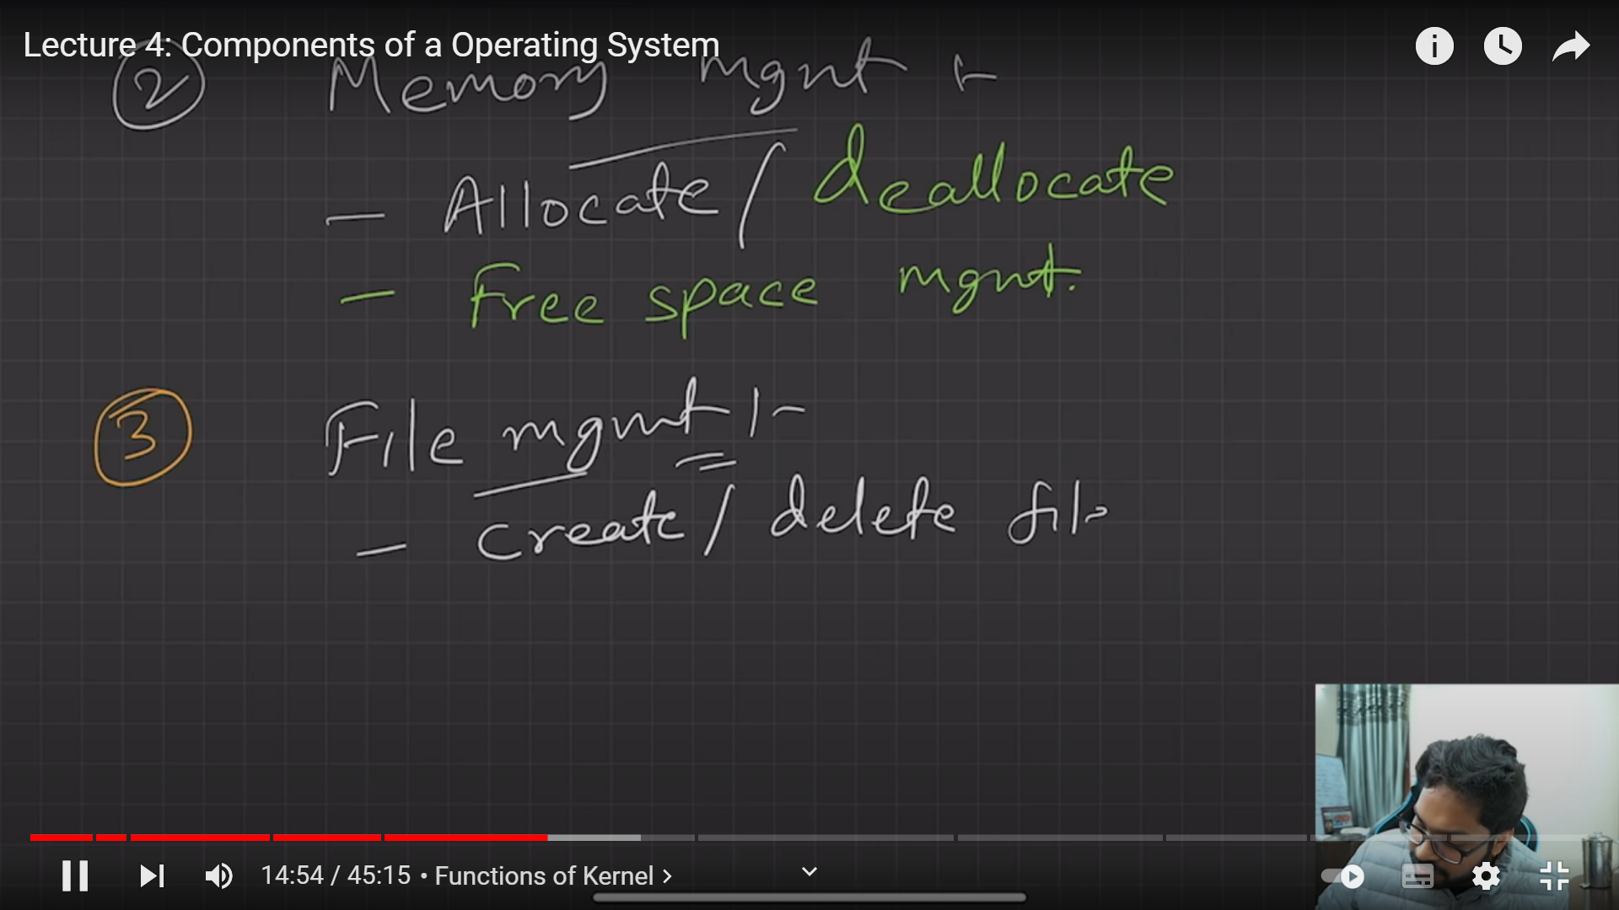

There are 4 types of kernel:

1. Monolithic kernel
2. Micro kernel
3. Hybrid kernel

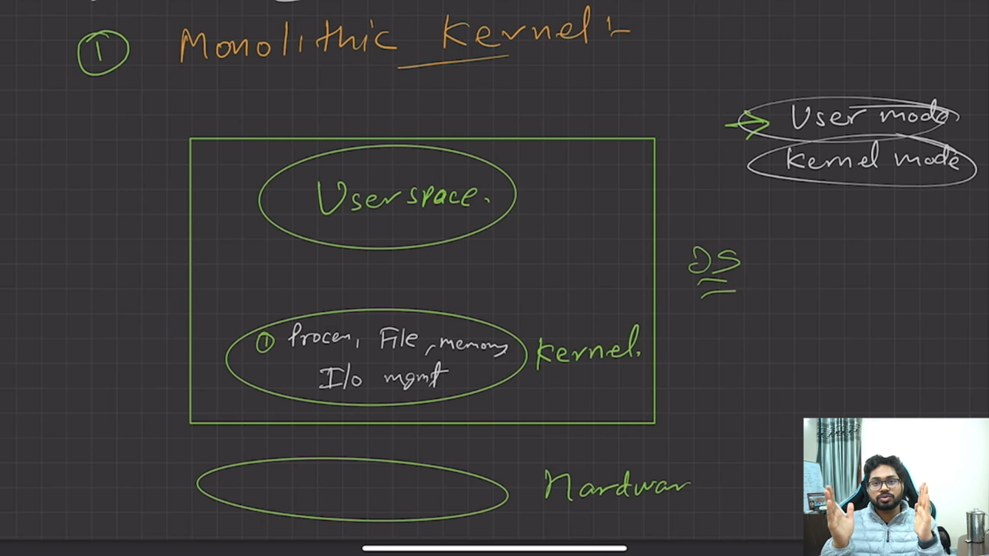

In monolithic all functions present inside kernel.

OS work in two Modes userMode and Kernel Mode and this mode is switch between using Software Interupt raise by OS. 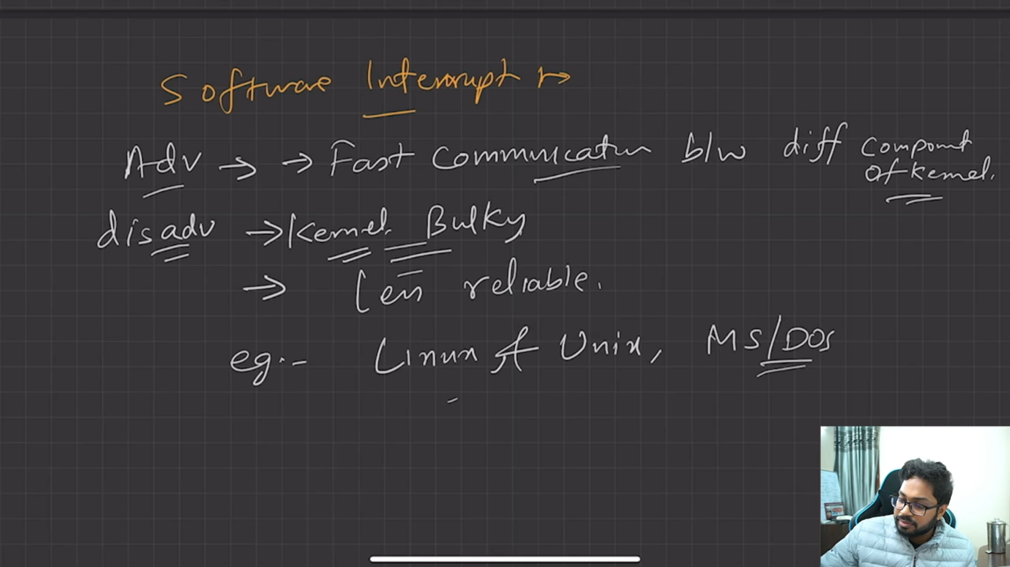

Micro kernel : Code functionalities present inside kernel and others are present in User Space.

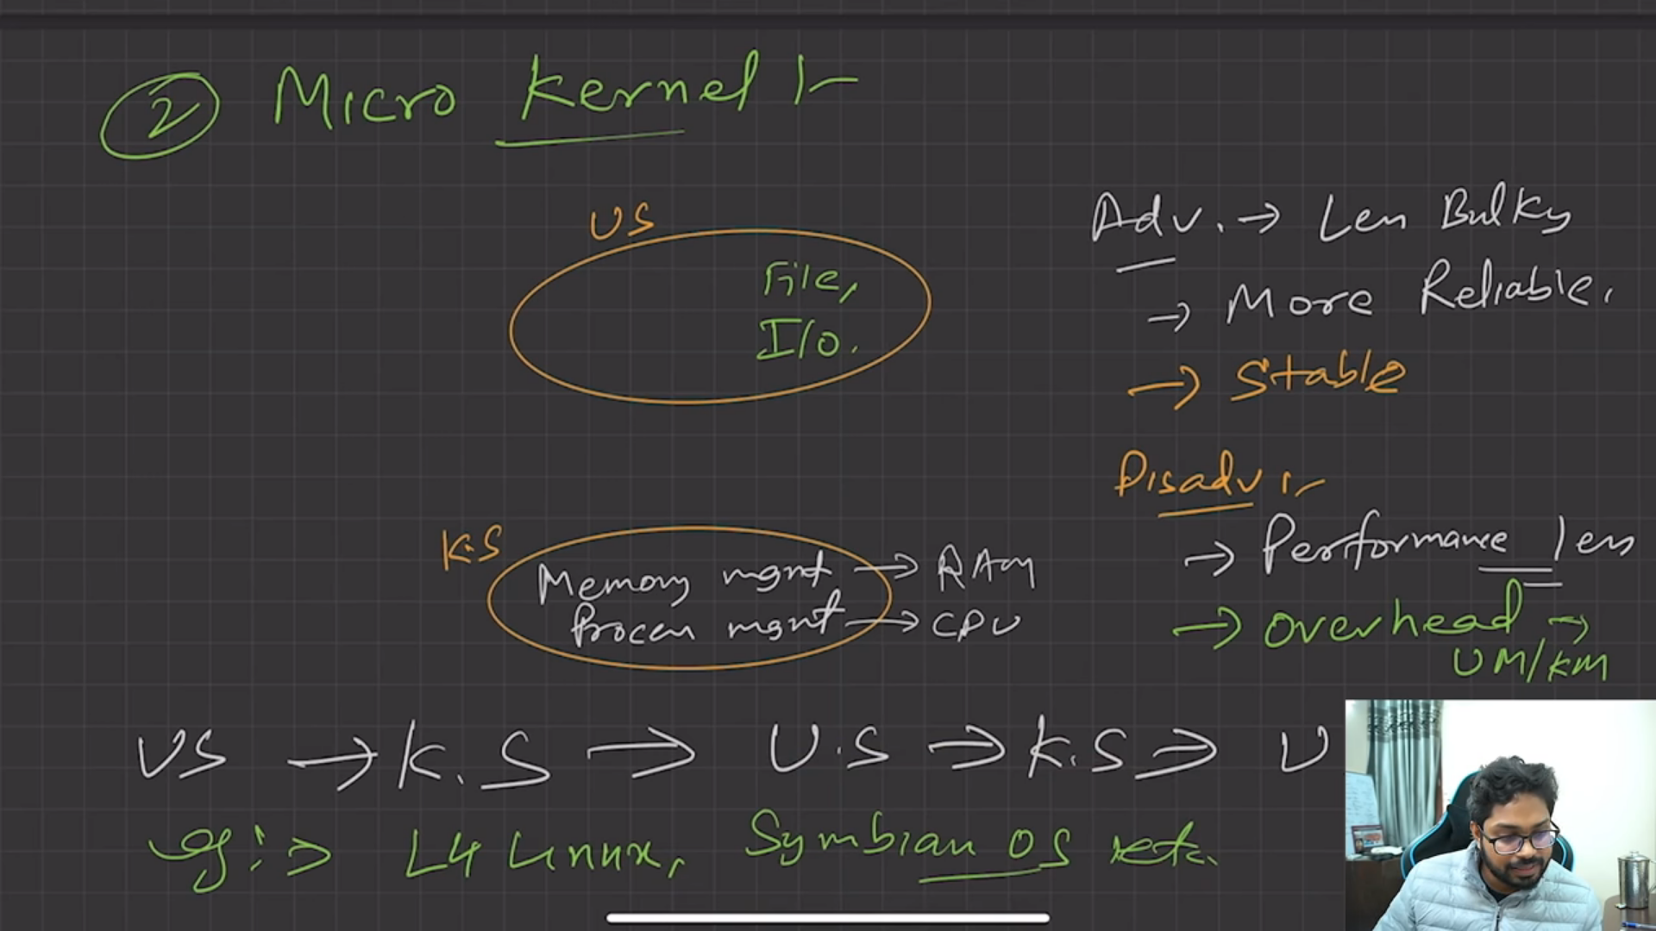

Communication between UserMode and Kernel Mode done By IPC( Inter Process Commnication) which uses 2 techniques that are Shared Memory and Message Passing.

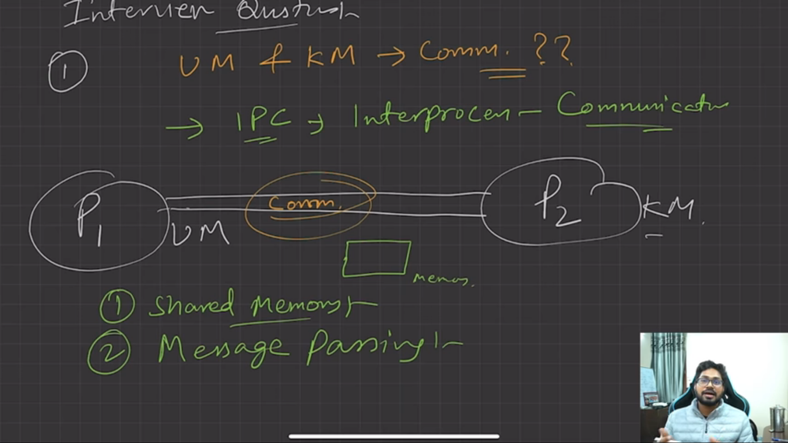

3rd. Hybrid Kernel

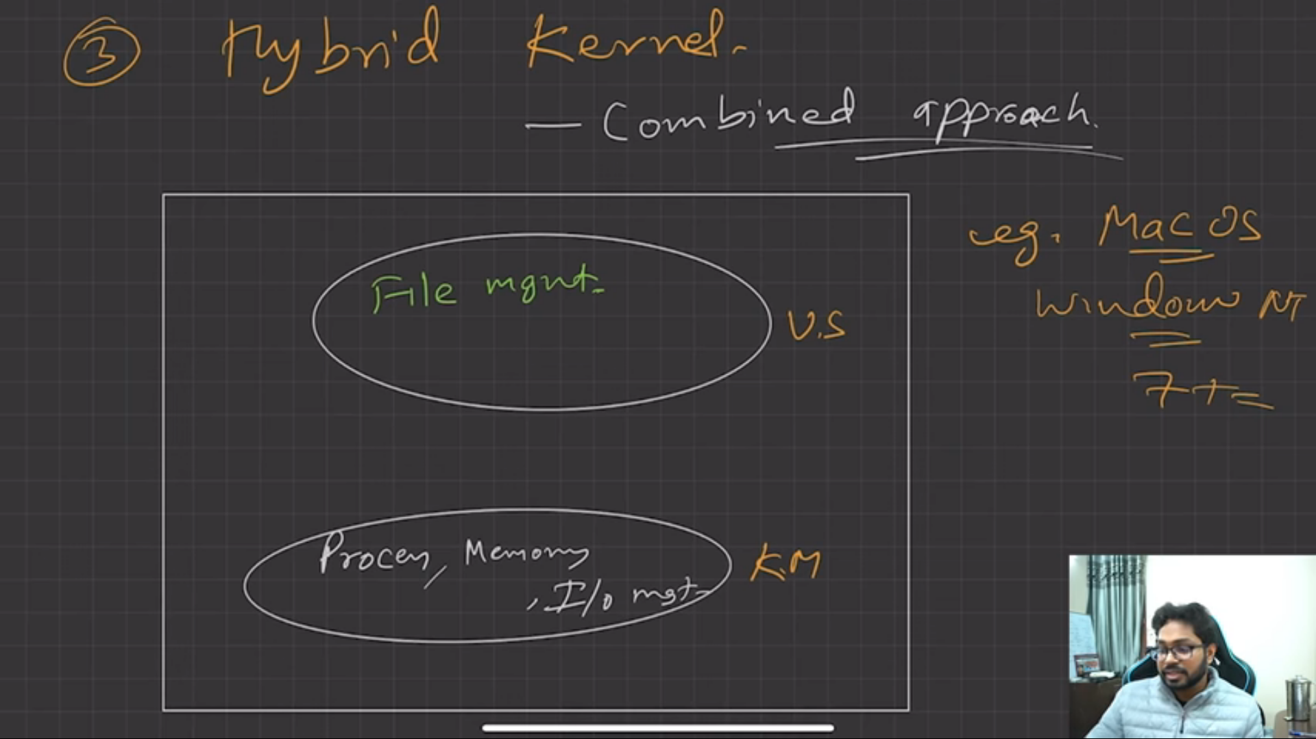

Notes Link for above Topics lecture 4: <https://drive.google.com/file/d/1tezd7cygozyZnP30Tc65fB6lrq2_KwaC/view>